**A TRAGEDY OF FLIGHT : A COPREHENSIVE CRASH ANALYSIS**

* INTRODUCTION
  1. OVERVIEW

**The aircraft is a machine that can fly in the air either carrying passengers and are goods. However, the air transport industry is seen as area of commerce where aircraft are used to transport people, carge and mail at the cheapest costs yet with the best safety measures employed.**

**The movement use only complete when there is ”safe arrival “,an aviation incident is delined as an occurrence , other then an accident, associated industry with the operation of an aircraft that affects are clouds affect the safety of operation(Air Safe. Com,2009).**

**1.2 PURPOSE**

**Vechicles used for cargo handling air travel or military purpose are referred to as aeroplane, plane or aircraft.**

**There are lot of plane types in the aviation industry such as passenger planes, cargo planes, military planes or private planes.**

* **PROBLEM DEFINITION AND DESING THINKING**

**1.EMPATHY MAP**

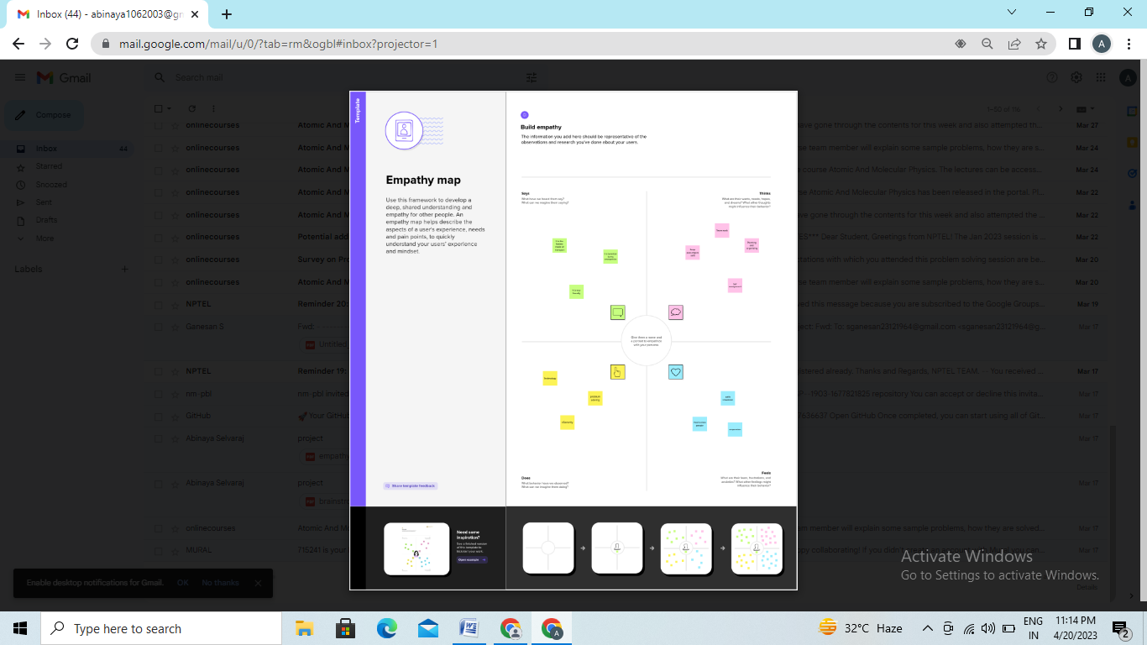

2.IDEATION AND BRAINSTROMING MAP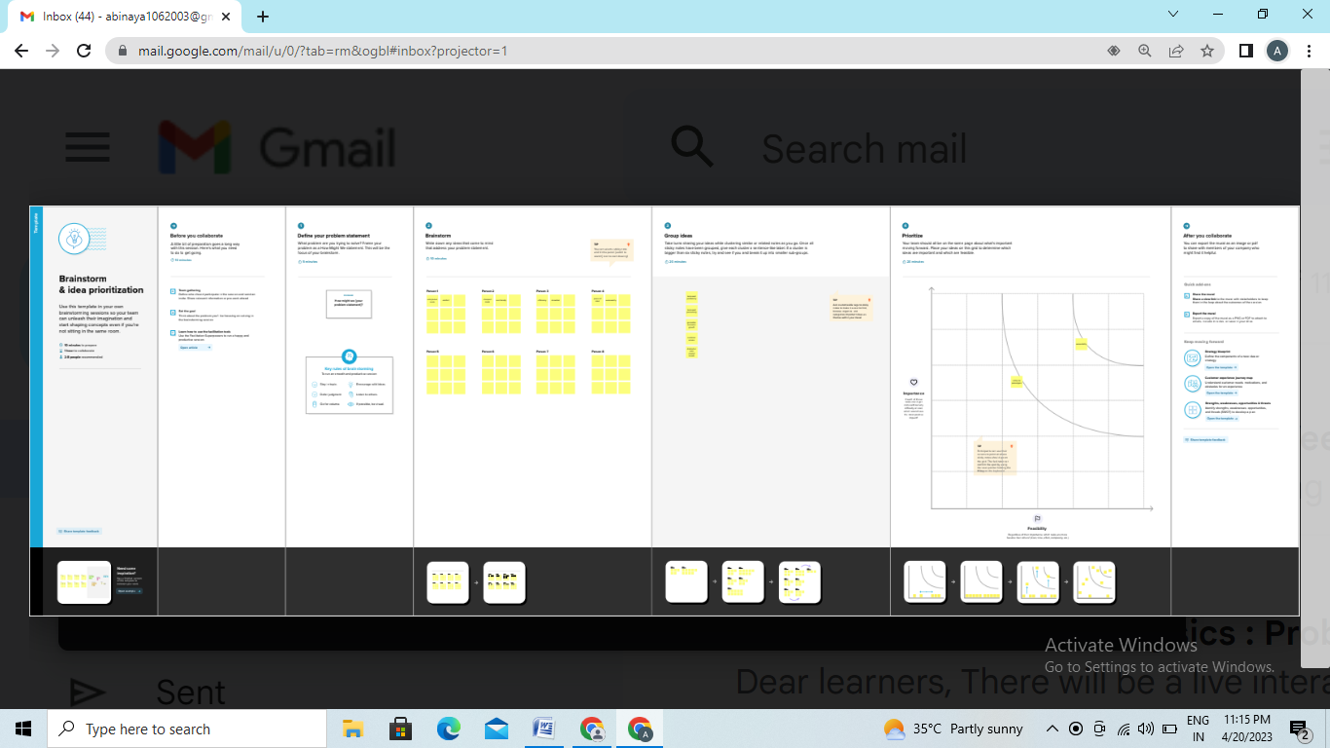

**3.RESULT**

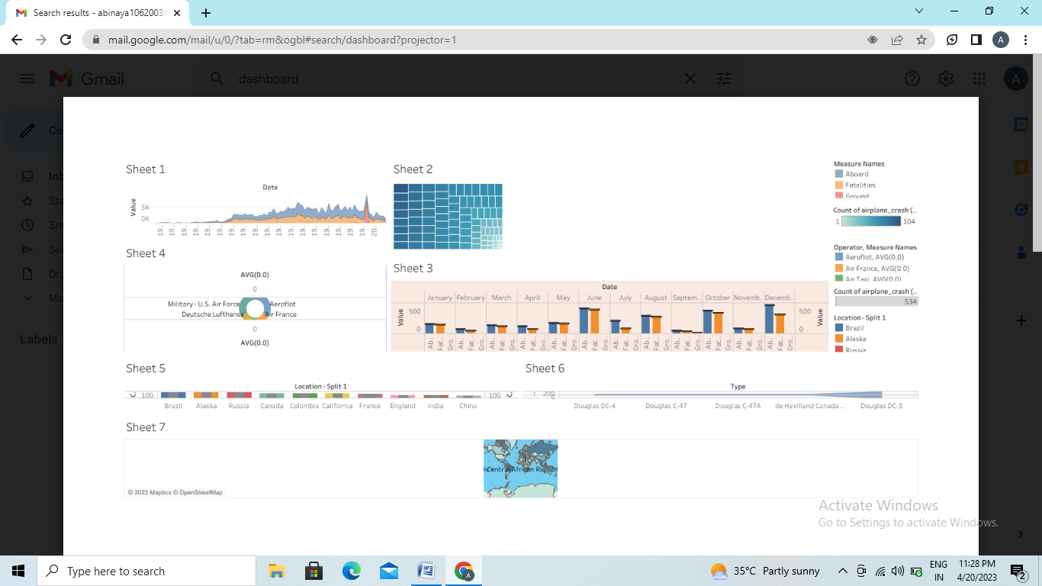

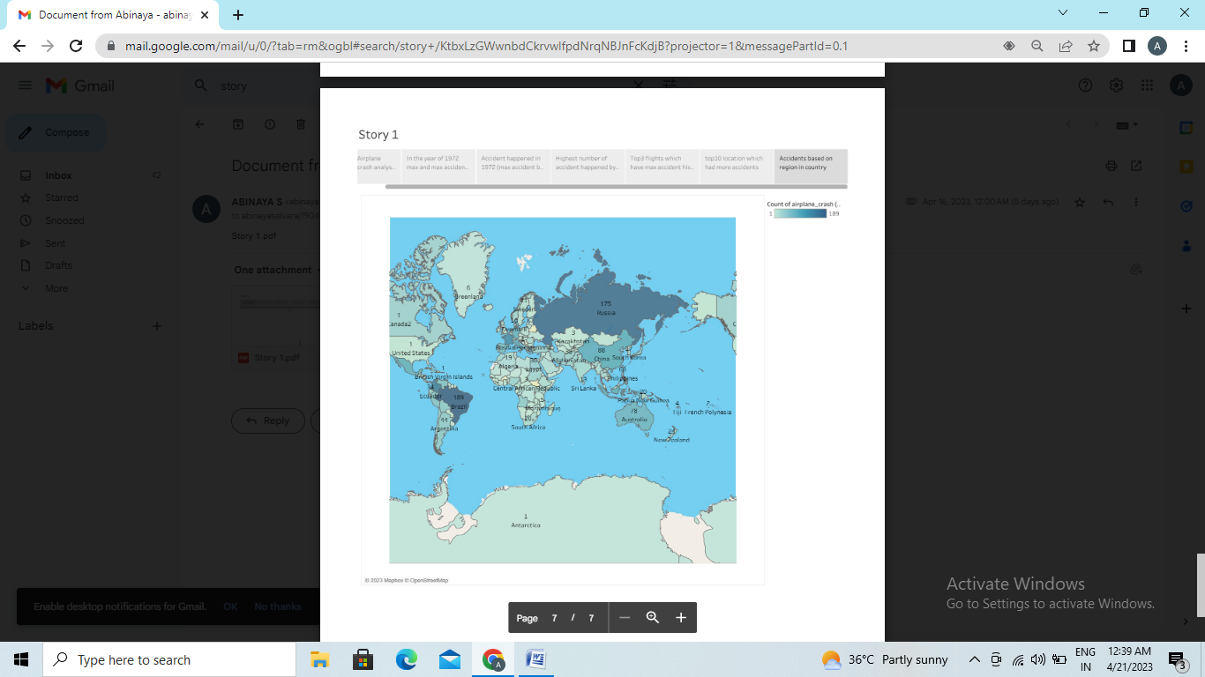

**4.ADVANTAGE AND DISADVANTAGE**

**ADVANTAGES**

* **No physical limits…,**
* **Very reliable transportation..,**
* **Long distance..,**
* **Higher cost..,**
* **Less storage capacity..,**
* **Restrictions on goods..,,**

**DISAVANTAGE**

* **It is more expensive than other types of transport because fule is expensive.**
* **Its more polluting than other more sustainable means of transport such as electric vehicles.**

**5.APPPLICATION**

**Typical aerospace application include aeronautical engineering, satellite communication, guidance and tracking system , destructive and non-destructive materials testing.**

* **Cockpit**
* **Engine**
* **Cabin**
* **Galley**
* **Cargo area**

**6. CONCLUSION**

* **A missing screw can jeopardize the whole aircraft.**
* **The constant maintenance and repair of aircraft may seem like a trivial job but they can prove to be fatal if not done properly.**
* **Lack of lubrication costed 88 lives, these are lessons the aviation industry learnt the hard way.**

**7. FUTURE SCOPE**

* **Aircraft engine market size was valued at USD 45.50 billion in 2021, and it is expected to reach a value of USD 104.65 billion by 2028, at a CAGR of 10.89% over the forcast period(2022-2028).**